# VECTORS

# Take n integers in a vector and print them

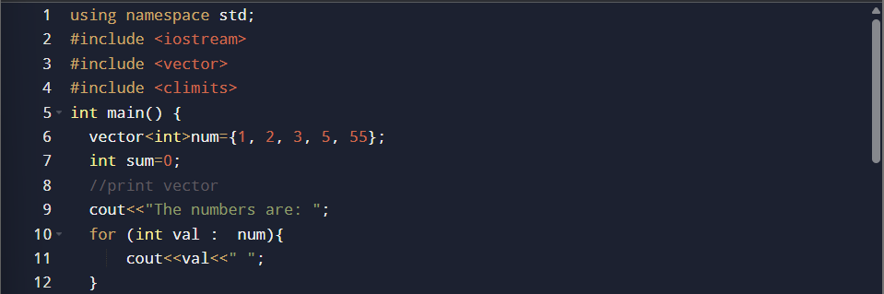

# Find **sum** of all elements

# Count how many are **even** or **odd**

# A computer screen shot of a number AI-generated content may be incorrect.Find the **largest** and **smallest** value

# Print the vector in **reverse order**

# Count how many numbers are **divisible by 5**

# Print only the **unique elements**

# Sort the vector in **ascending** or **descending** order

# Find the **second largest** element

# Swap the **first and last** elements

# Print only the **prime numbers** from the vector

# Find the **average** and count how many numbers are above average

